Boudjemai Chahinez
ENSTA

Axis II Workshop 2

Research Topic:
Detection of heavy metals using marine bioindicators in desalination plant discharge areas.

Step 1 : Defining the Research Question

Research Question:
How are marine bioindicators used to detect and monitor heavy metal contamination resulting from desalination plant discharges?
Keywords:
Heavy metals, marine bioindicators, desalination plants, effluents, coastal pollution, biomonitoring.

Step 2 : Initial Exploration with Elicit

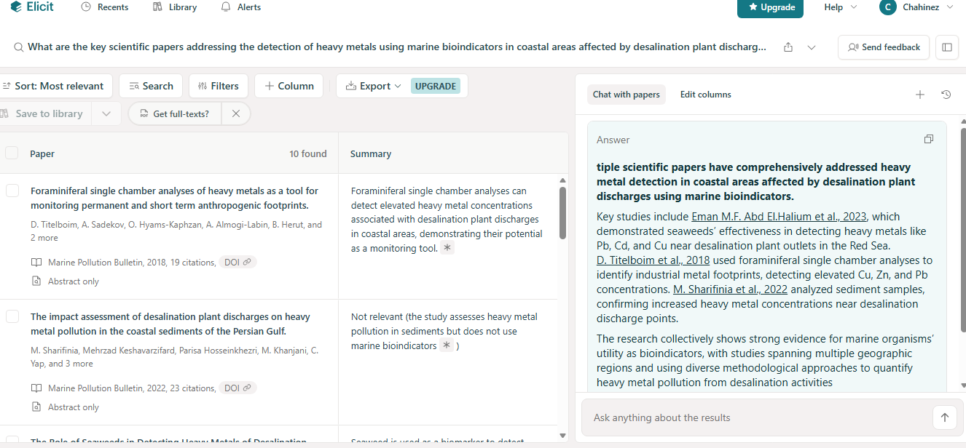

Step 3 : Cross-Verification with Semantic Scholar

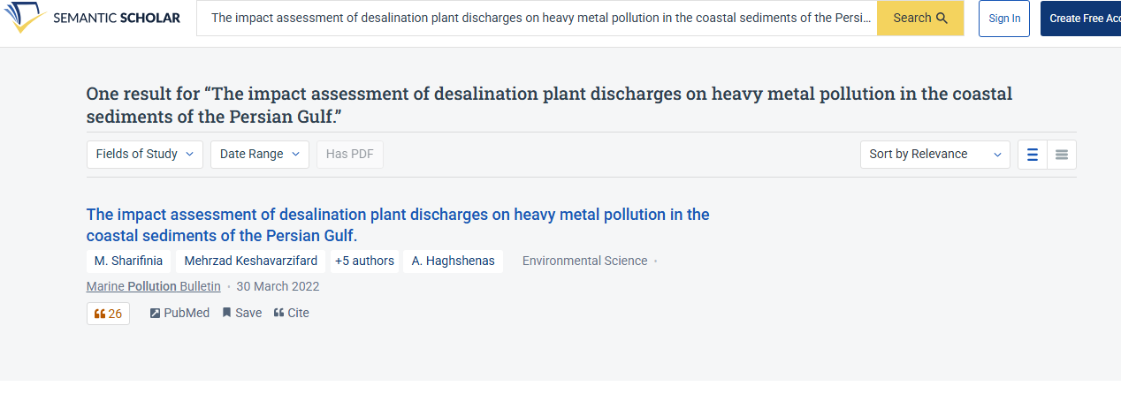
.

Step 4 : Critical Evaluation with Scite
The selected article was searched in Scite using its DOI. However, Scite did not return classified citation contexts (supporting, mentioning, or contradicting). This indicates that the article has limited or no indexed citation analysis within the platform at the time of consultation. This result highlights the importance of combining multiple tools when evaluating scientific literature.

Step 5 : Reference Management with Zotero

References (APA style)
Sharifinia, M., Keshavarzifard, M., Hosseinkhezri, P., Khanjani, M. H., Yap, C. K., Smith, W. O., Daliri, M., & Haghshenas, A. (2022). The impact assessment of desalination plant discharges on heavy metal pollution in the coastal sediments of the Persian Gulf. Marine Pollution Bulletin, 178, 113599. https://doi.org/10.1016/j.marpolbul.2022.113599

